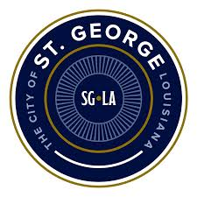

The City of St. George City Charter Commission will meet at 6 p.m. Wednesday, August 28. The meeting will be held at St. George City Hall, 14100 Airline Hwy, St. George, LA 70817.

# Agenda

* Welcome & Roll Call
* Introductions
* Goals and Objectives
* Process Overview and Timeline
* Context Setting & Other Models
* Charter Elements Overview
* Charter Structure
* Key Decision Points
* Next Steps

If you need special accommodations prior to the meeting, call 225.395.9005.